TEST CASES PRACTICE
Facebook – Post Block
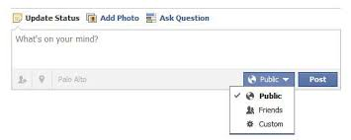
TITLE: | Verify that user enter at least one alphanumeric character.
DESCRIPTION: | Every time that user enters at least one alphanumeric character, the post button is enabled.
EXPECTED RESULTS: | Post button enabled :  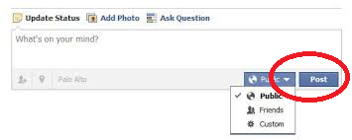

TITLE: | Check that the default select button is public.
DESCRIPTION: | Every time that user accessed to post block, the select button is selected by default as public.
EXPECTED RESULTS: | The button selected by default.  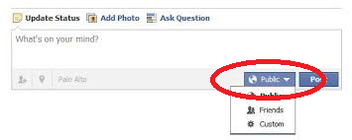

TITLE: | Verify that select button can deploy a list with options.
DESCRIPTION: | Every time that user clicked on the select button, this deployed a list with three options: Public, Friends and Custom.
EXPECTED RESULTS: | Select Button displayed with three options: Public, Friends and Custom.  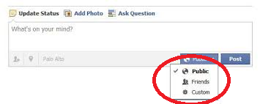

TITLE: | Verify that clicking on the button, the entered text is published.
DESCRIPTION: | Every time that user clicks the button, the text is displayed on the wall of publications.
EXPECTED RESULTS: | A text posted on the block.  

TITLE: | Verify that the published texts have a recent order.
DESCRIPTION: | Every time that user posts a text on the wall, should be displayed in the order of most recent to least recent.
EXPECTED RESULTS: | Text published by the most recent the least recent.  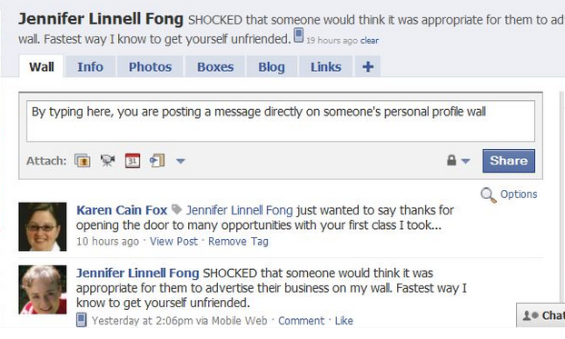

NAME: BRAYAN GABRIEL ROSAS FERNANDEZ

JHASMANY ELVIS QUIROZ OLIVERA

COURSE: QADEV04

